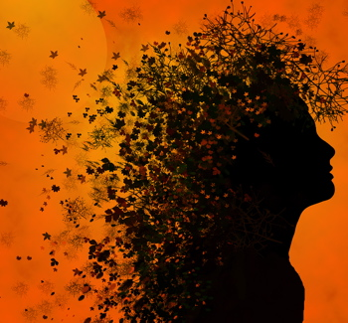
What is this day?
It is the day of Autumn Equinox.
What is the meaning of this day?
It is the time of balancing.
What are the elements that balance at this time?
Tonight the light and the darkness are equals.
After this day of balancing, which will prevail?
From this day forward, darkness will prevail over light.
How do we recognize ourselves on this day?
We turn away from light. We embrace the darkness. We find the darkness within ourselves.
Who helps us?
Our goddess helps us.
What is our Goddess?
She is the brightness and the shade, the ash and the fire, the evening and the morning.
Who is our Goddess?
She is the Virgin of Light, the Crone of Darkness, the Mother of Time.
Where is our Goddess?
She is in our hearts in all seasons of the turning year.
Who is our Goddess?
Behold, she is ourselves.

