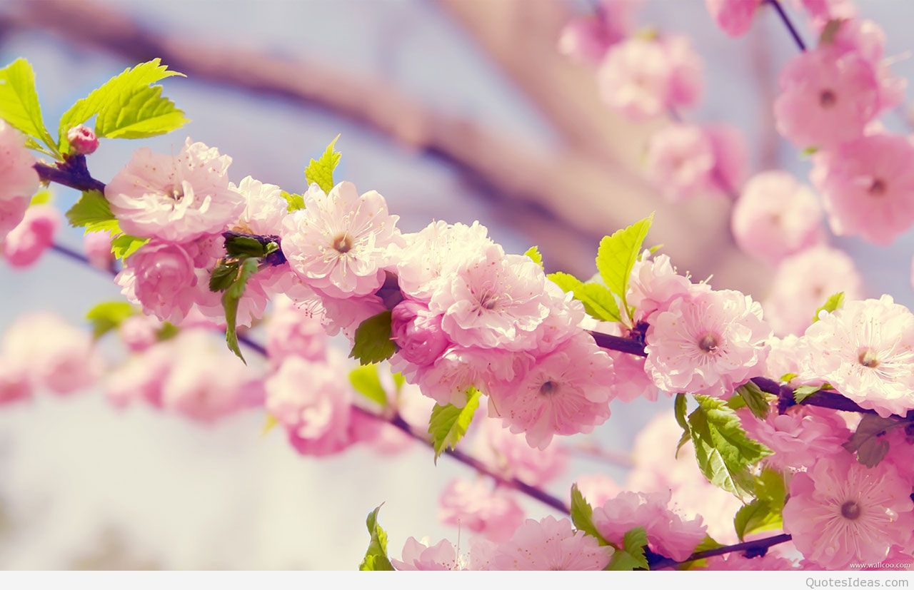
Vernal Equinox Antiphonal Chant
(This could be a choral response with the group, or a person North, South, East, West reading if you take out the indents. You can also change it to “What is this day?”)
What is this night?
It is the night of the Vernal Equinox.
What is the meaning of this night?
It is the night of balancing.
What are the elements that balance on this night?
Tonight the darkness and the light are equals.
After this night of balancing, which will prevail?
From this night forward, light will prevail over darkness.
How do we recognize ourselves on this night?
We turn away from darkness. We embraced the light. We find the light within ourselves.
Who helps us?
Our Goddess helps us.
What is our Goddess?
She is the shade and the brightness, the fire and the ash, the morning and the evening.
Who is our Goddess?
She is the Virgin of Light, the Crone of Darkness, the Mother of Time.
Where is our Goddess?
She is in our hearts in all seasons of the turning year.
Who is our Goddess?
Behold, she is Ourselves.

