Celebrating Lammas - School of the Seasons

Page 1 of 3

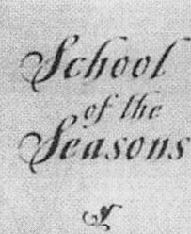

Waverly

FITZGERALD

CORRESPONDENCE

COURSE

ARCHIVES

SUBSCRIBE

CONTACT

STORE

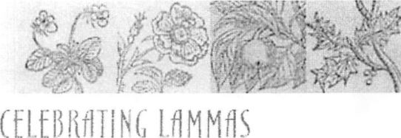

The year is 1100. The date is  
August 1. The monks in the abbey  
at Gloucester are celebrating the  
holy-day of St. Peter in Chains.

One of the monks wakes from a  
strange dream in which God  
promises to strike down the wicked  
King who has abused the Holy  
Church. His superior, Abbot Serlo,  
on hearing of the dreams sends a  
warning to the King, William the  
Red, who has oppressed all of  
England with taxes and disgusted  
many with his licentiousness and  
blasphemy. Red, as he is called,

receives the message the following day while preparing to indulge in one  
of his favorite sports, hunting, in the New Forest. Although there are no  
longer any people dwelling in the New Forest — they were all cleared out  
by Red's father, William the Conqueror — there are rumors that it's a  
hotbed of pagan activity. And August 2 is an important pagan holy-day.  
The Saxons call it Lammas, the Loaf-Mass. William the Red laughs at the  
warning from the monks and goes out hunting. A short time later, he is  
dead, struck in the chest by a stray arrow, and his brother, Henry, who  
was in the hunting party is riding hot-foot for Winchester and the crown.

Now some people say that William the Red was a Lammas sacrifice, that having made a wasteland of his kingdom, he was killed by the people (or the Gods) as a sacrifice to bring new life to the land. And some people say his brother Henry has him assassinated. And some people say that both versions are true.

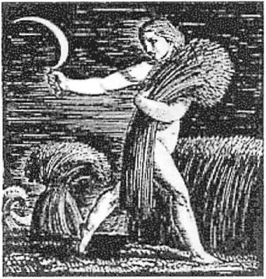

This story comes to my mind when I think of Lammas because I spent ten years researching a medieval novel set in the time of William the Red and Henry. But this tale of sacrifice and hunting, a dying King and a wasted land, embodies many of the dominant themes of Lammas, one of the four seasonal quarter-days, and perhaps the least well-known.

Visit our: purchase Lamma: chock full celebratir holiday!

The Celts celebrate this festival from sunset August 1 until sunset August 2 and call it Lughnasad after the God Lugh. It is the wake of Lugh, the Sun-King, whose light begins to dwindle after the summer solstice. The Saxon holiday of Lammas celebrates the harvesting of the grain. The first sheaf of wheat is ceremonially reaped, threshed, milled and baked into a loaf. The grain dies so that the people might live. Eating this bread, the bread of the Gods, gives us life. If all this sounds vaguely Christian, it is. In the sacrament of Communion, bread is blessed, becomes the body of God and is eaten to nourish the faithful. This Christian Mystery echoes the pagan Mystery of the Grain God.

<http://www.schooloftheseasons.com/lammas.html>

7/5/2005

|  |  |
| --- | --- |
| Celebrating Lammas ■ | • School of the Seasons Page 2 of 3 |
|  | Grain has always been associated with Gods who are killed and dismembered and then resurrected from the Underworld by the Goddess- Gods like Tammuz, Osiris and Adonis. The story of Demeter and  Persephone is a story about the cycle of death and rebirth associated with grain. Demeter, the fertility Goddess, will not allow anything to grow until she finds her daughter who has been carried off to the Underworld. The  Eleusinian Mysteries, celebrated around the Autumn Equinox, culminated in the revelation of a single ear of corn, a symbol to the initiate of the cyclical nature of life, for the corn is both seed and fruit, promise and fulfillment.  You can adapt the themes of Lughnasad and Lammas to create your own ceremony for honoring the passing of the light and the reaping of the grain.  Honoring the Grain God or Goddess |
|  | Bake a loaf of bread on Lammas. If you've never made bread before, this is a good time to start. Honor the source of the flour as you work with it: remember it was once a plant growing on the mother Earth. If you have a garden, add something you've harvested—herbs or onion or corn—to your bread. If you don't feel up to making wheat bread, make corn bread. Or gingerbread people. Or popcorn. What's most important is intention. All that is necessary to enter sacred time is an awareness of the meaning of your actions.  Shape the dough in the figure of a man or a woman and give your grain- person a name. If he's a man, you could call him Lugh, the Sun-King, or  John Barleycorn, or the Pillsbury Dough Boy, or Adonis or Osiris or  Tammuz. Pauline Campanelli in The Wheel of the Year suggests names for female figures: She of the Corn, She of the Threshing Floor, She of the  Seed, She of the Great Loaf (these come from the Cyclades where they are the names of fertility figures), Freya (the Anglo-Saxon and Norse fertility Goddess who is, also called the Lady and the Giver of the Loaf), the Bride (Celtic) and Ziva or Siva (the Grain Goddess of, the Ukraine,  Hungary, Yugoslavia and Czechoslovakia).  Feast  Like all holidays, Lammas calls for a feast. When your dough figure is baked and ready to eat, tear him or her apart with your fingers. You might want to start the feast with the Lord's Prayer, emphasizing the words "Give us this day our daily bread." The next part of the ceremony is best done with others. Feed each other hunks of bread (or gingerbread people or popcorn), putting the food in the other person's mouth with words like "May you never go hungry," "May you always be nourished," "Eat of the bread of life" or "May you live forever." Offer each other drinks of water or wine with similar words. As if you were at a wake, make toasts to the passing summer, recalling the best moments of the year so far. |
|  | Corn Dolly  Another way to honor the Grain Goddess is to make a corn doll. This is a |

<http://www.schooloftheseasons.com/lammas.html>

7/5/2005

|  |  |
| --- | --- |
| Celebrating Lammas ■  * . 1 | ■ School of the Seasons Page 3 of 3 |
|  | fun project to do with kids. Take dried-out corn husks and tie them together in the shape of a woman. She's your visual representation of the harvest. As you work on her, think about what you harvested this year.  Give your corn dolly a name, perhaps one of the names of the Grain  Goddess or one that symbolizes your personal harvest. Dress her In a skirt, apron and bonnet and give her a special place in your house. She is all yours till the spring when you will plant her with the new corn, returning to the Earth that which She has given to you.  Food for Thought  Lammas is a festival of regrets and farewells, of harvest and preserves.  Reflect on these topics alone in the privacy of your journal or share them with others around a fire. Lughnasad is one of the great Celtic fire- festivals, so if at all possible, have your feast around a bonfire. While you're sitting around the fire, you might want to tell stories. Look up the myths of any of the grain Gods and Goddesses mentioned above and try re-telling them in your own words.  Regrets: Think of the things you meant to do this summer or this year that are not coming to fruition. You can project your regrets onto natural objects like pine cones and throw them into the fire, releasing them. Or you can write them on dried corn husks (as suggested by Nancy Brady  Cunningham in Feeding the Spirit) or on a piece of paper and burn them. |
|  | Farewells: What is passing from your life? What is over? Say good-bye to it. As with regrets, you can find visual symbols and throw them into the fire, the lake or the ocean. You can also bury them in the ground, perhaps in the form of bulbs which will manifest in a new form in spring.  Harvest: What have you harvested this year? What seeds have your planted that are sprouting? Find a visual way to represent these, perhaps creating a decoration in your house or altar which represents the harvest to you. Or you could make a corn dolly or learn to weave wheat. Look for classes in your area which can teach you how to weave wheat into wall pieces, which were made by early grain farmers as a resting place for the harvest spirits.  Preserves: This is also a good time for making preserves, either literally or symbolically. As you turn the summer's fruit into jams, jellies and chutneys for winter, think about the fruits that you have gathered this year and how you can hold onto them. How can you keep them sweet in the store of your memory?  Back to Home Paae  Back to July Calendar |
|  | Content (c) 1998 Waverlv Fitzaerald. Do not reproduce without Dermission.  Website Desian © 2002 JPC Web Desian Services. Last updated 6/30/03  New Moon in Cancer. |

<http://www.schooloftheseasons.com/lammas.html>

7/5/2005