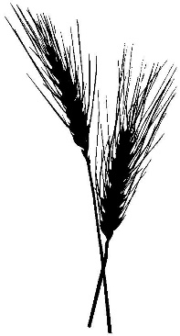
Lammas
N: What is this night?
S: It is the night of Lammas.
E: What is the meaning of this night?
W: It is the feast of bread.
N: What do we honor on this night?
S: We honor the fruits of the earth, our ongoing sustenance.
E: After this feast of bread, what will we do?
W: We will tend and store our harvest, preserving what is necessary to life.
N: How do we recognize ourselves on this night?
S: We knead the dough. We bake the good bread. We call upon the Mother who gives us our daily food.
E: Who helps us?
W: Our Goddess helps us.
N: What is our Goddess?
S: She is the benevolence of our Mother Planet, the rich gifts of her soil, the nourishment of our bodies.
E: Who is our Goddess?
W: She is the Virgin of Light, the Crone of Darkness, the Mother of Time.
N: Where is our Goddess?
S: She is in our hearts in all seasons of the turning year.
E: Who is our Goddess?
W: Behold, she is ourselves.

