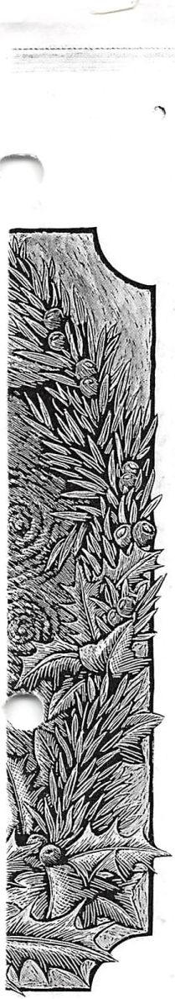

———-

or Kids

>r, optional)" ind enough water e airtight. This is tasting it.

— I

**Evergreen Trees**

A

n evergreen tree with twinkling lights  
reflected in shiny glass ornaments and  
with gaily wrapped packages underneath

it is for many of us a treasured childhood memo-  
ry and a beloved holiday tradition. In years past  
it was a tradition that many of us felt we had to  
abandon once we had accepted the ways of the  
ancient gods, but today’s Pagans recognize their  
own traditions in the guise of the new religion.

When the cold days and long, dark nights of December are upon us it is a good time to reflect upon the meaning of this magical tree. To the ancient Greeks the fir tree was and still is the symbol of Artemis, the Moon Goddess, who pre­sides over childbirth, and who carries a pinecone- tipped wand. In Phrygia the goddess Cybele adorned a fir tree with violets in memory of her beloved Attis, and this tree was used in rites to bring about his resurrection. Among Germanic people the fir tree trimmed with ornaments and lit candles at Yule (yule is an Anglo-Saxon word meaning wheel) is called tannenbaum or “sacred tree.” This name is very similar to the Celtic word tinne, the sacred holly, or even earlier, the ever­green oak. In Scandinavian countries the World Tree is often depicted as an evergreen with a pair of deer or harts nibbling at its base, its roots in the underworld and its branches in the upper world. In the Ukraine a similar tree is often inscribed on magical eggs, and evergreen with two deer at its base and in its branches are every sort of bird, fruit, and flower. Its roots are in a chalice or caul­dron and it is called Berehenya—great goddess. Such images certainly are the origins of the tree we trim at Yule.

The earliest trees were decorated with actu­al fruits and nuts, pine cones, and candles. Later, cookies and confections were added, and pine cones and walnuts were gilded. Eventually, artifi­cial fruits were used, and other shapes as well. These were made of spun cotton, tinsel wire, pressed cardboard, or printed in chromolithogra­phy or rotogravure. In the late 1800s blown glass ornaments began to be produced in Germany, and it is believed that the first glass ornament, blown into a gingerbread mold, was made in the shape of a pine cone, symbol of Artemis, goddess of rebirth. The earliest glass ornaments were faithful reproductions of fruits and berries, but these rapidly were joined by other forms, realistic or fanciful, mundane or magical.

It is apparent that trees were first decorated with fruits and nuts and artificial flowers to bring about the return of spring and fertility, warmth,

and light, and to restore and maintain the bal­ance between darkness and light, coldness and warmth, and death and rebirth.

Today we Pagans can trim our trees with shiny glass balls that reflect candlelight and sun­light, or delicate glass fruits and berries that have been handed down to us from grandparents and great grandparents. We can make ornaments our­selves of marzipan or gingerbread or woven wheat, or strips of paper glued into rings, and rings into chains.

In order to trim this magical tree it must first be obtained, and the magic can begin there. If you cut your own tree, first you might wish to cast a circle according to your ways around your­self and the tree. Then explain to the spirit of the tree the purpose for which it is being cut. Here at Flying Witch Farm we grow our own trees for Yule, but we always leave the lower portion of the tree to regrow. Commercial tree farms, how­ever, frown on this practice. When you have made your statement and called upon the Lord and Lady, then cut the tree swiftly. A chainsaw gjves the kindest cut, and then sever the tree’s spirit with a ritual knife. It is traditional to leave an offering afterward.

If you cannot cut a tree yourself and must buy one already cut, you might wish to conse­crate it in the four elements. Splash it with salt­ed water, smoke its branches with incense, and carry a candle around it before it is consecrated to the Lord and Lady. Finally, if for any reasons you cannot use a real tree but only an 'artificial one, don’t despair. What is imitative magic any­way but substituting one thing for another? Just be sure to state something like, “this is not plas­tic and wire, but a fragrant fir tree,” before con­secrating it in the four elements and in the names of the gods.

At Yule, the darkest night of the year, we kindle our Yule log here at Flying Witch Farm to help the lord of Light return. On this night the darkness that is the Great Mother brings forth the light, which is her divine child, as She did in the beginning. As we perform the ancient rites we light our tree of life, the Tree of resurrection and rebirth.

—By Pauline and Dan Campanelli