Page 1 of 4

August 2 - Lammas Celebration

Home

Printer Friendly Version

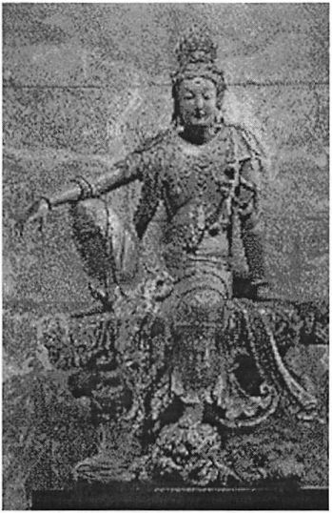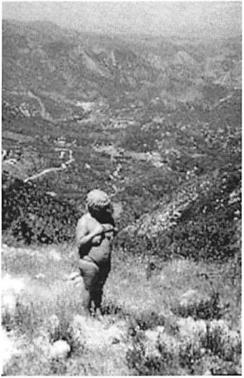

The first harvest of summer is when the early apples  
come in, blueberries are abundant, as are raspberries,  
mangoes, nectarines, peaches, apricots, watermelon &  
cherries. It is also the time when the first harvest of  
corn & grain takes place. What is sweeter & more  
enjoyable than tasting the summer's first tender ears of  
corn? Silver Queen or Peaches & Cream are among the  
taste triggers that bring to mind August & the  
abundance of the earth's generosity, of warm days,  
sunshine, shores & picnics.

The goddess & guardian of the harvest is Habondia, the  
generous one, she who is abundance. The Great Mother  
Goddesses of the world are overflowing with their  
goodness: Kwan-Yin, guardian of mothers, children &  
childbirth; Hestia, the keeper of the hearth & home;  
and, Lilith, the first bride of Adam, Arianrhod & Yemaya.

In

connection  
with the  
wider world  
than our  
own, it is a  
time to  
remember  
that not all

peoples of the world are experiencing abundance that  
we may have in our lives. Due to war & interventions  
that are in opposition to the nature of the Goddess, the  
natural rhythms & gifts of the earth have been curtailed  
or limited for some. It is good to send out to the  
universe energy & wishes for peace & abundance.

Lammas is also a time for blessing animals. At your  
ritual, you may not want to bring your animals along,  
but it is appropriate to remember them in the ritual  
circle. The donkeys throughout history & all over the  
world have helped in the building, the travel & the  
development of civilization. It was a donkey that carried  
Mary & Joseph into Jerusalem. Dogs have been friends,  
companions, guardians, workers & iifesavers throughout  
history; cows, sheep, pigs & goats have given us meat,  
milk, cheese & warmth since they were domesticated by  
women. We certainly want to remember the blessing of  
our cats who have been mousers, psychic connectors,

teachers & companions throughout all time. It is a time to bless the wild animals left in the world; in  
the sky, on the earth & beneath the sea.

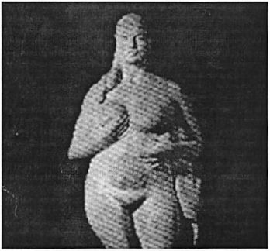

As the wheel of the year turns, the first harvest  
corresponds across the wheel to the February 2nd  
celebration of the earth's quickening ( see CoolWomen's  
Imbolc feature). The Great Mother has moved through  
the seasons from the promise of new life in February to  
the fulfillment of that promise with the harvest  
beginning in August.

August reminds us also that we are in the waning time  
of the year. The persistent song of the kadydids tells us  
that in six weeks, there will be frost. Persephone, who  
strayed from her friends at the Summer Solstice (see  
CoolWomen's Midsummer's Eve feature) is now on  
the path to the Underworld & her mother, Demeter, is  
beginning to search for her & feels a chill.

<http://www.coolwomen.ca/coolwomen/cwsite.nsf/0/6BB4E8309222BF5385256650004C4A>... 7/5/2005