4th Chakra-Heart
*Read Affirmations, Attributes and Mudras cards
*Take a mirror and sing sweetly to yourself over and over the song;
“How could anyone ever tell you, you were anything less than beautiful?
How could anyone ever tell you, you were less than whole?
How could anyone fail to notice that your loving is a miracle?
How deeply you’re connected to my soul.”

“I will be gentle with myself, I will love myself, I am a child of the universe, being born each moment.

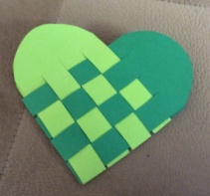
*Woven heart project: Write love messages to self or decorate it as you wish on the heart

*Free-style journaling

