o? *Q / Op*

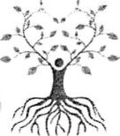

My roots go down, down to the earth

My roots go down, down to the earth  
My roots go down, down to the earth  
My roots go down

;y

ifcf

JW

®' ’ Ancient Mothers, we hear you calling

Ancient Mothers, we hear your song  
Ancient Mothers, we feel your laughter  
Ancient Mothers we taste your tears.

Ancient Fathers

Deep peace, of the precious earth to you

Deep peace of refreshing winds to you  
Deep peace of lifegiving waves to you  
Deep peace of the healing fire to you

Deep Peace of the Mother Earth to you

Deep peace of the Father Sky to you

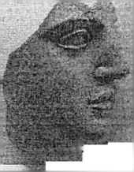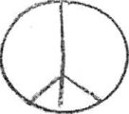

Deep peace of the Brother Sun to you Deep peace of the Sister Moon to you.



I will be gentle with myself; I will love myself I am a child of the Universe, being born each moment