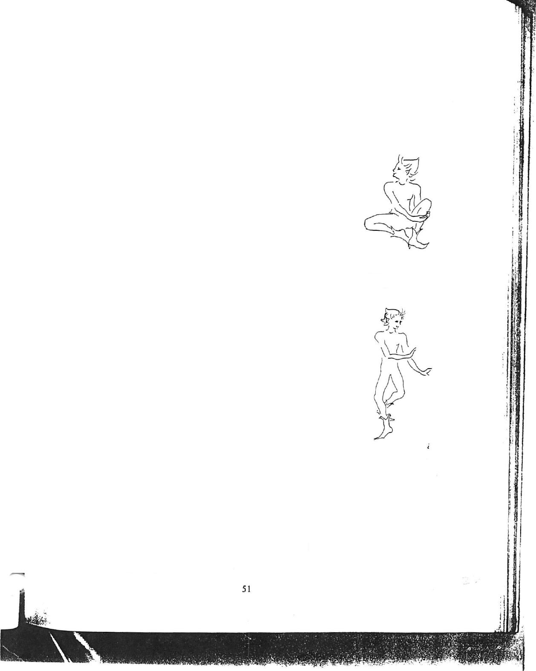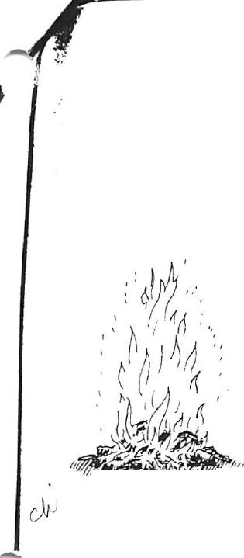2. Midsummer

The celebration of the summer solstice may be June 21, the longest day of the year, or June 24, the official calendar Midsummer Day and the feast of St. John the Baptist. Ancient peoples, watching the sun reach its highest point at this time, lit evening bonfires to encourage it to shine and ripen their crops. In many parts of the country bonfires still blaze at this time, songs are sung and the half-way point of the year marked. For many people the day is associated with fairies, as immortalized by Shakespeare in A Midsummer Night’s Dream. In the play, Puck speaks of “…we fairies, that do run, By the triple Hecate’s team, From the presence of the sun, Following darkness like a dream”, while Oberon and Titania follow on:
`Through this house give glimmering light
By the dead and drowsy fire:
Every elf and fairy sprite,
Hop as light as bird from brier,
And this ditty, after me
Sing, and dance it trippingly.'
`First rehearse this song by rote: To each word a warbling note, Hand in hand, with fairy grace, Will we sing. and bless this place.'

- ,
4 x •
The Joyful Feast of St. John'
`Then cloth the joyful feast of St. John the Baptist take his turne, When bonfiers great with loftie flame, in every towne doe burne; And yong men round with maides, doe daunce in every streete, With garlands wrought of Motherwort, or else with Vervain sweete, And many other flowre faire, with Violets in their handes, Whereas they all do fondly thinke, that whosoever standes, And thorow the flowres beholds the flame, his eyes shall feele no paine. When thus till night they daunced have, they through the fire amaine With striving mindes doe runne, and all their hearbes they cast therein, And then, with wordes devout and prayers, they solemnely begin, Desiring God that all their illies may there consumed bee Whereby they thinke through all that yeare from
Augues to be free '
From a 16th Century poem by Thomas Kirchmeyer.
Midsummer Night
The sun goes down,
The stars peep out,
And long slim shadows
Flit about.

In velvet shoes
The quiet dark
Comes stepping soft
O'er wood and park.

And now the world
Is fast asleep;
And fays and elves
Their revels keep.

They fly on the backs of the grey-winged moths, They skim on the dragon-flies green and gold
On shimmering dew-wet grass they alight,
Tiny petal-skirts whirl, gauzy wings unfold.

The fairies are dancing beneath the moon
Hush! See the shimmer of their twinkling shoon!

Elizabeth Gould

