Vernal Equinox 2018
Becky, Carol, Joy, Julie
Overview:
Brunch first
11-3 at Joy’s home
Theme: equal scales, call the youth in each woman; day to observe power to heal the earth, heal each other; glee and Laughter, Frolic, Whimsy, Magic, mischievous

Timing and Outline:
We arrive at Joy’s at 8 a.m. for set up

11-11:45 Arrival/direct where coats, journal, basket go/Eat: (45 min)
Breakfast prayer (Becky)

On this day of celebration, we begin with a feast in gratitude for life itself. At this time of spring awakening, we experience more light in our lives. Did you know the added light makes the birds sing more? So as the gentle breeze of spring sunlight arrives, we give thanks for all we have and the bounty Mother Nature will soon provide to each of us this season physically and spiritually. Now we celebrate all this by nourishing our bodies…..HO!

(11:45 to 12:15) Blessings (30 min):
Welcome blessing: brush with rosemary (Carol)
Welcome blessing: Herbal spray (Becky)
“Welcome Ladies: May the scent of spring awaken in you joy and laughter,
Creativity and divine providence…go forward with an open heart.”
Welcome blessings (Julie)

12:15-12:20 Open the Circle and Call in the directions with center: (5 min) (All)
From: Binder-
---East- We join with the earth and with each other.
To bring new life to the land, to restore the waters, to refresh the air
South- We join with the earth and each other.
To renew the forests, to care for the plants, to protect the creatures
West- We join with the earth and with each other.
To celebrate the seas, to rejoice in the sunlight, to sing the song of the stars
North- We join with the earth and with each other.
To re-create the human community, to promote justice & peace, to cherish our children.

SKY-We join with the earth and with each other.
We join together as many and diverse expressions of one loving mystery.
For the healing of the earth, and the renewal of all life- Blessed Be!
12:20-12:25 Introduction (Joy) 3 parts (5 min) (Joy)

1-: We’Moon 2010 Spring Equinox –
“With bone cold winter behind, we celebrate the life force, rejoicing in a fresh, clear,
Bright spring day. Tender stems and shoots push through the fertile soil, buds explode and the Egg of Spring hatches a living creation! Eostre, Goddess of the divine fertile female, calls to the spirit of youth in each woman.” We’Moon 2010, Ffiona Morgan

History: Vernal Equinox is the time when light and dark are equally balanced. All sleeping seeds awaken. In the myth of Persephone and Demeter, this is the time of her physical birth where she rejoins her mother leaving the darkness.

A shift takes place from the earth energy of winter to the air element of Spring. From the cold darkness of the earth and stone and roots of trees, the sap begins to rise, the breeze begins to warm and soothe us. Remember the seed that dies, falls in to the dark ground and is reborn as the sprout, the seedling. We experience life in its fullest, with the buds on the trees opening, the bountiful flowers blooming, the range of greens to open our hearts and the magic of babies and birth.

Let us rejoice in the abundance of Earth. Today is a new day of promise and renewal- may we claim our womanly strength. Feel our energy, youthfulness, and the powers of REBIRTH.

2-Although the solstices have much stronger folklore relating to the Fey folk attached to them the equinoxes do have their share as well, with the spring equinox falling close to La na Cailleach – the day of the Cailleach (March 25th). La na Cailleach itself has both pagan and fairy connections, being a day in folklore when some believe the primal goddess the Cailleach relents and allows spring to arrive, or others say transforms into the goddess Bride; the Cailleach is also a figure connected directly and indirectly to the Queen of Elphame.

3-
This year we are celebrating our ritual on March 25th. Interestingly enough, I noticed
Two other historic rituals that happen at this time;

- Hillaria or Laughing Day (Roman)…which focuses on Glee and Laughter, during the resurrection of Earth….So hopefully we can spread some of that around today…..

- In the Jewish Tradition, PURIM is celebrated. It is a day to observe women’s power over universal destruction and the victory of female strategies….

May our own lives rise in triumph, and our collective power alter positive change for our planet, for all beings on this precious EARTH.
12:25-12:30 Mary Oliver Poem:(Carol) Such Singing in the Wild Branches (5 min)

12:30-12:45 Visualization with brief journaling (Julie) (15 min) (don’t have it)
Birthing, finding your story, power to heal, rebirth, playfulness,
12:45 -1:05 Scavenger/Hunt Intro- Carol (20 min)

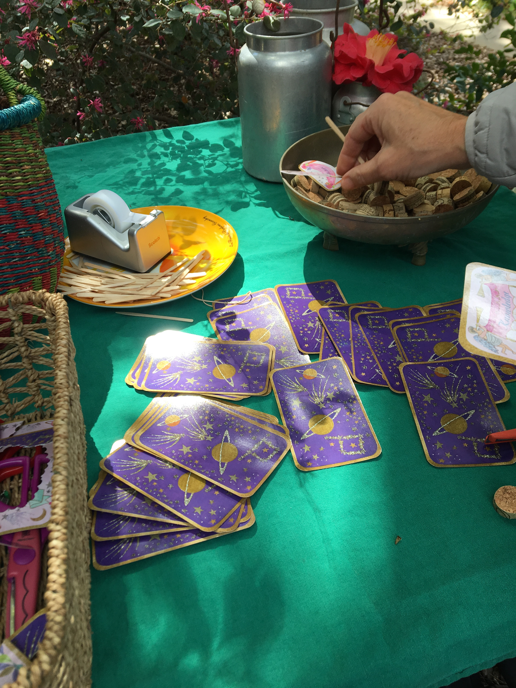
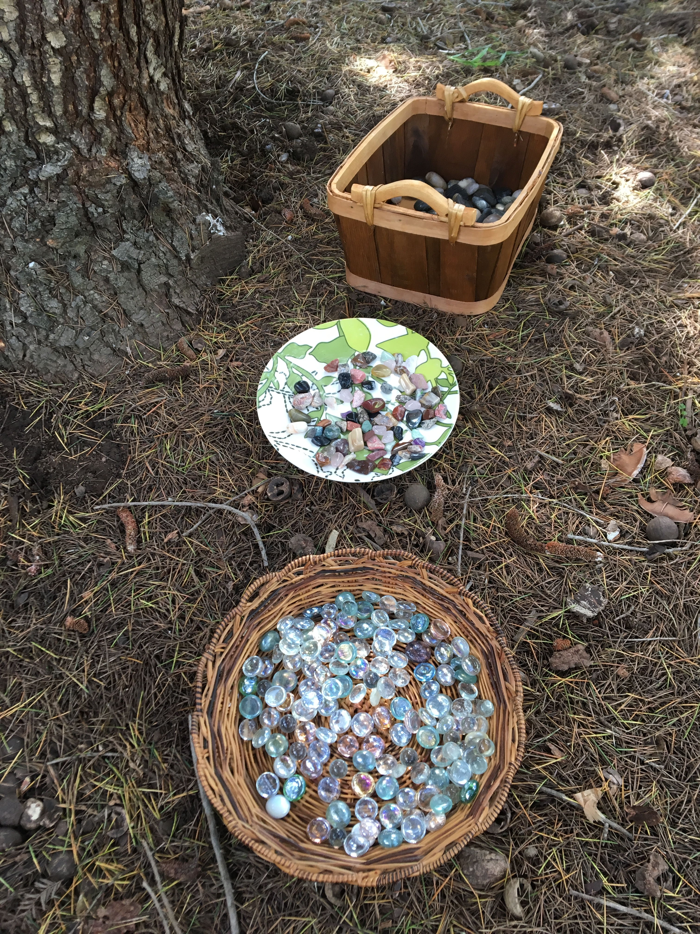
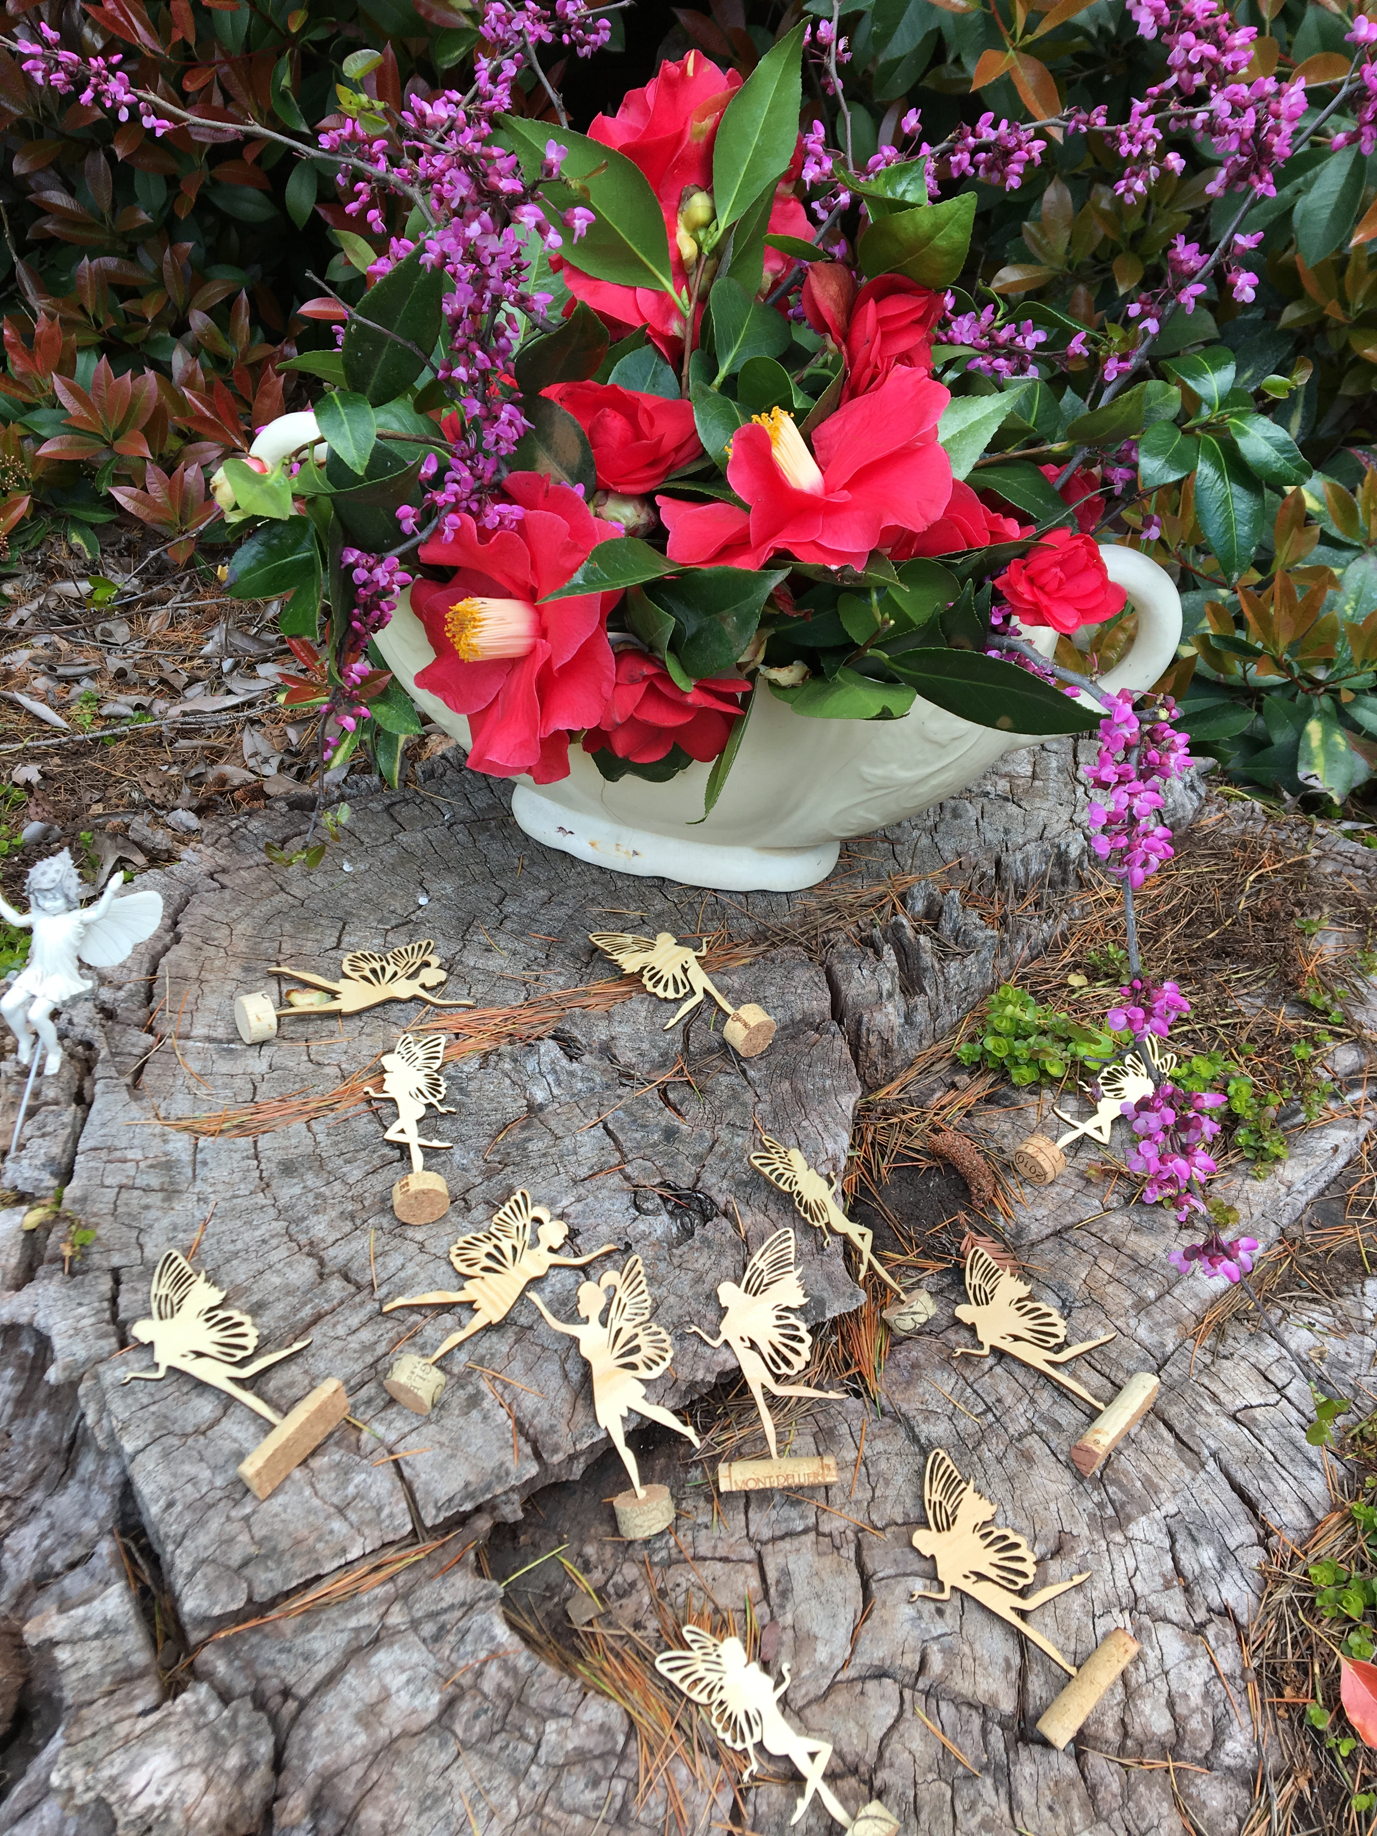
Find the 4 hidden spaces for the fairy gardens and fairies- 4 stations (Don’t have a picture of the boat.)

“You need to frolic and have fun finding your treasures to put in your basket. There will be 4 things you will discover- fairy, fairy boat, magical stones, affirmation signs-in various places. When you have what you need, look for Becky-“
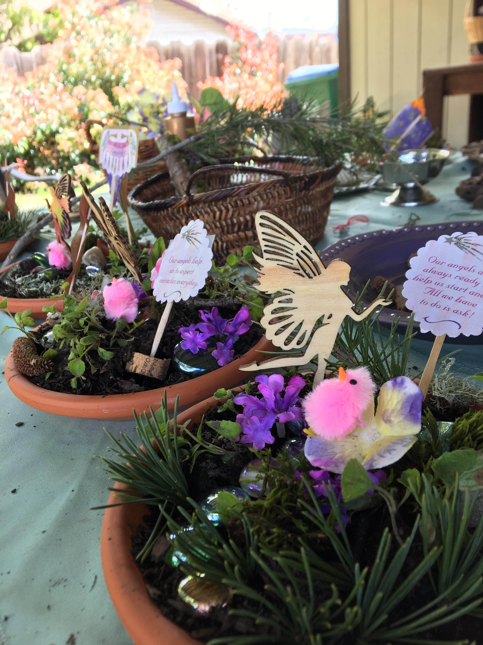
1:05-1:35 Building garden Intro- Becky (30 min)………………

1:35-1:50 (Dancing and movement (15 min) Intro- Joy

1:50-2:50 Sharing time (1 hour) Intro- Julie

2:50-3:00 (10 minute) closing: poem and closing the circle (all)
Same as opening directions, but alter
“We join with the earth to We LEAVE with the earth

Do/Bring
Retyping Blessing (Carol)
Talking stick (Becky)
Paper flowers (Becky)
Clothespin fairies –guardian of your nature space (Becky & Carol)
Make with clothespin, string or yarn, (Becky, Carol)
Markers (Becky)
Flowers from (all)
Violets (Becky dig up)
Rocks (Carol and Joy)
Terracotta plates (Joy)
Dirt (Carol)
Colored Glass (Joy)
Cards cut and glued to sticks (Carol)
Look through home for fairy garden things (all)
Fairy boat (Carol)
Fairy houses (Julie)
Fairies (Julie)
Altar gatherings (all)—create a garden: plants, flowers, and rocks
Hot water for tea container: Becky
Provide tea, coffee and juice (need to decide who will bring)

