2017 Candlemas-3 Meditation Prompts
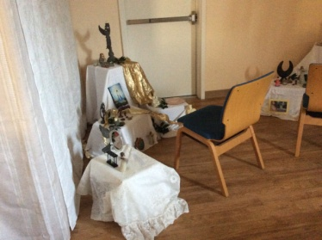
Meditation Station
Two beautiful meditation stations were set up next to, but turned away from each other. This allowed for more women to access the station. There was a 5 minute timer at each station to allow for all a turn at the stations. Each had the same prompt.
Gaze on the goddesses, gods and objects of beauty that surround you. If you wish, gaze at yourself in the mirror. Surrounded by beauty, within and around you, ask yourself, “What creative energy have I been nurturing, that I am now ready to bring forth?”
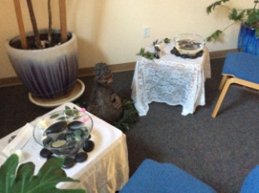
Scrying Station

Allow your mind to float and your gaze to rest on the water of the sacred well.
You may:
- Without asking a specific question, allow information to come to you regarding this time in the wheel of the seasons.
- Hold a question in your mind’s eye and allow the answer to come to you.
Journaling Station
(All along the dining tables were different sets of tarot or divination cards with their books. The following prompts were also scattered around. This was an opportunity to use the cards, journal or both.)
In order to create a-new, sacrifices and changes must be made. The important thing is this: to be able at any moment to sacrifice the “you” that you are now for the “you” that you could become.
- What are you willing to give up to further your goals?
- What are you willing to fight to preserve within or around you?
- What relationships are you willing to commit to and cultivate?
- What would you like to be harvesting at the end of this turning of the wheel?

